**University Of Jeddah**

**College Of Computer Science and Engineering**

**Software Engineering Department**

**TalentDesire**

**Advisor: Dr. Khaled Al-Raddah**

|  |  |  |  |
| --- | --- | --- | --- |
| # | ID | Name | Mail |
| 1 | **1847141** | **Abdulrahman Saeed Al-Suhimi** | **1847141@uj.edu.sa** |
| 2 | **1944989** | **Owis Mohammed Bukhari** | **1944989@uj.edu.sa** |
| 3 | **1947384** | **Mohammed Ahmed Hakami** | **1947384@uj.edu.sa** |

**Table of Contents:**

Chapter 1: Planning 1

1.1 Description of the context (Scope) and the problem to solve 2

1.2 Aims 2

1.3 Objective 2

1.4 Report outline 3

1.5 Project plan 4

1.6 Skills & Tools 4

Chapter 2: Problem Understanding 5

2.1 Stakeholders definition 6

2.2 Detailed Description of the background (project domain) 6

2.3 Literature Review 6

2.4 Comparative review 7

2.4.1 Gaps in Available Research 9

Chapter 3: Analysis Phase 10

3.0 Functional Requirements 11

3.1 Non-Functional Requirements 12

3.2 Hardware Requirements 12

3.3 UML Diagrams 13

3.4 Data Collection Instruments 19

Survey design 19

Survey Analysis 20

Survey results 20

Chapter 4: Design Phase 23

4.0 System Architecture 24

4.1 Diagrams 25

4.2 User interface design 27

Chapter 5: Conclusion 31

5.0 Conclusion 32

5.1 Future Work 32

**Table of Figures:**

Figure 1 Report Outline 3

Figure 2 Skillshare 7

Figure 3 Pluralsight 8

Figure 4 Detailed Use Case Diagram 13

Figure 5 Add/Remove Course/Service Use Case Diagram 14

Figure 6 Add/Remove Skill Use Case Diagram 14

Figure 7 Class Diagram 15

Figure 8 Detailed Class Diagram 16

Figure 9 Sequence Diagram 17

Figure 10 Survey Flyer 19

Figure 11 Pie Chart for question 1 20

Figure 12 Pie Chart for question 2 20

Figure 13 Pie Chart for question 3 21

Figure 14 Pie Chart for question 4 21

Figure 15 Pie Chart for question 5 21

Figure 16 Pie Chart for question 6 22

Figure 17 Pie Chart for question 7 22

Figure 18 System Architecture 24

Figure 19 State Diagram for Login Model 25

Figure 20 State Diagram for Request Service Model 26

**List of Tables:**

Table 1 Project Plan 4

Table 2 Functional Requirements 11

Table 3 Non-Functional Requirements 12

Table 4 Login Model 16

Table 5 Request Service Model 16

Table 6 Add Service/Course Model 16

Table 7 Enroll to a course 17

Table 8 User Interface Design 28

# Chapter 1: Planning

**“In this section, we will discuss about the context and the problem we will solve, aims, objectives, report outline and our project plan.”**

## 1.1 Description of the context (Scope) and the problem to solve

When we starts our collage career we had issues in some subjects like not being able to have the full knowledge, if you miss some class we have hard time to recap, so the problem is the student cannot find anyone to help if needed, he needs to look up and search for another students and doctors by himself, thus our program helps students and doctors to get help sooner, easier, scheduled, and in an effective way.

Some of the futures of our system is to make sure the students have the help they need, and book sessions.

And for those talented student and teachers will have the opportunity to earn money be teaching other student and the teachers can vouch for the talented student so they can have credibility.

## 1.2 Aims

As student when we first started going to college, we suffered a lot in the beginning.

It took us a long time to find resources and help, so our main goal is to develop an application where students can easily find help, whether it from talented students or doctors, so creating a community will make sure every student can find help if needed.

Regarding talented students, they can develop the gift they have by practicing and teaching.

The aim for a talented student is to grow their skills and build connections that can help them in their professional career.

## 1.3 Objective

* Improve the standard of learning and teaching.
* Interpret students' needs of requiring help.
* To ensure they get help in a short time manner and in a high-level of expertise.
* Giving the student more than one opportunity to understand the lesson.
* Apply paid lessons, and free lessons.
* Gather students/doctors in a community.
* Establish connection between students.
* Design user friendly application.
* To differentiate between talented and average students.
* To reduce amount of time spent on helping students.

## 1.4 Report outline

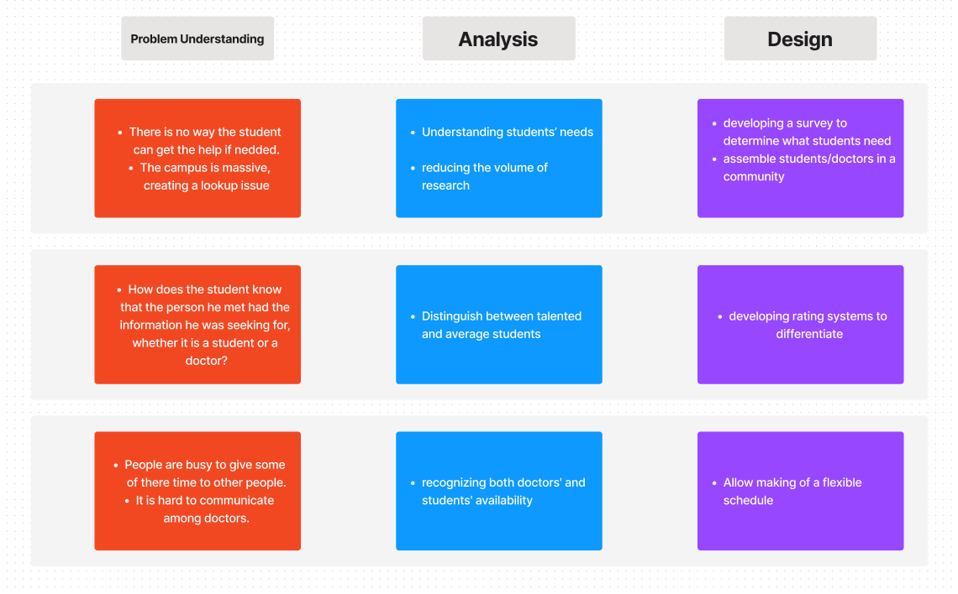

Figure 1 Report Outline

## 1.5 Project plan

|  |  |  |  |  |  |
| --- | --- | --- | --- | --- | --- |
| **Title** | **Assignees** | **Status** | **Phase** | **Start Date** | **End Date** |
| Description of the context (Scope) and the problem to solve | Abdulrahman | Completed | Planning | Sep 14, 2022 | Sep 14, 2022 |
| Aims | Owis | Completed | Planning | Sep 14, 2022 | Sep 14, 2022 |
| Objectives | Mohammed | Completed | Planning | Sep 14, 2022 | Sep 14, 2022 |
| Report Outline | Abdulrahman, Owis, Mohammed | Completed | Planning | Sep 14, 2022 | Sep 14, 2022 |
| Project Plan | Abdulrahman, Owis | Completed | Planning | Sep 14, 2022 | Sep 14, 2022 |
| Stakeholders’ definition | Abdulrahman | Completed | Problem Understanding | Sep 25, 2022 | Sep 25, 2022 |
| Detailed Description of the background (project domain) | Abdulrahman | Completed | Problem Understanding | Sep 25, 2022 | Sep 25, 2022 |
| Literature Review | Owis | Completed | Problem Understanding | Sep 25, 2022 | Nov 1, 2022 |
| Comparison criteria definition | Mohammed | Completed | Problem Understanding | Sep 25, 2022 | Nov 1, 2022 |
| Comparison results and the feasibility study | Mohammed | Completed | Problem Understanding | Sep 25, 2022 | Nov 1, 2022 |
| Functional & Non-Functional Requirements | Abdulrahman | Completed | Analysis | Oct 6, 2022 | Oct 6, 2022 |
| Hardware Requirements | Abdulrahman | Completed | Analysis | Oct 6, 2022 | Oct 6, 2022 |
| UML Diagrams | Abdulrahman, Owis | Completed | Analysis | Oct 6, 2022 | Nov 8, 2022 |
| Data collection instruments (Data logger) | Owis, Mohammed | Completed | Analysis | Oct 6, 2022 | Nov 8, 2022 |
| System Architecture | Abdulrahman, Owis | Completed | Design | Oct 20, 2022 | Nov 7, 2022 |
| Diagrams (If Applicable) | Abdulrahman, Owis, Mohammed | Completed | Design | Oct 20, 2022 | Nov 6, 2022 |
| User interface Design (If Applicable) | Owis, Mohammed | Completed | Design | Oct 20, 2022 | Nov 7, 2022 |

Table 1 Project Plan

## 1.6 Skills & Tools

Talent Desire will be developed using the latest techniques in the industry, In the Planning and Designing we will use Figma to visualize the UI/UX and in the Development and Implementation field we will be using React native to build a cross-platform project to ensure Accessibility and Usability for any user from anywhere, Firebase will be the Back end and the only API for our database and storage.

# Chapter 2: Problem Understanding

**“In this section, we will discuss about the problem how we found it difficult and how we are going to solve it”**

## 2.1 Stakeholders definition

Stakeholders are any employee/student, or anyone has an account in UJ Active Directory, Facility members are also included, which will prevent any unauthorized access, Firebase is also a stakeholder only in this demo, and any user can be a Talented member which will have more features.

* + University Of Jeddah.
  + Students.
  + Teaching crew (Doctors/Professors).
  + Database.
  + Talented Students.

## 2.2 Detailed Description of the background (project domain)

TalentDesire is aimed for students as an Educational, Financial, Beneficial tool/program to help with educational matters, technical issues, sharing knowledge and socializing, as a Student in UJ in my personal perspective I find it difficult to find someone who would be able to help me with anything that I came up with and I found this more disturbing to face especially when it comes to Software, the students are more aware of this issue, they tried so many times to communicate using a WhatsApp groups, Telegram groups or any Social media platforms and it is also a lot problematic, because we are talking about maybe 300-700 members are in the same chat so you cannot catch any messages you missed. The ideal of our application is that you will find any Talented member with the skill that you are looking for, you can schedule a meeting with him, socialize, and ask for guidance. Our solution is to create a platform that gather UJ student together to share their skills and experience.

## 2.3 Literature Review

The purpose of the project under consideration is to find talented students to share their skills and help other students in need by creating a platform for them to display their capabilities and knowledge.

First, when we started or collage journey, we had rough time with gaining knowledge of some subject and finding people to help you it is near impossible thing to do, so creating a platform that gather people with each other and exchange knowledge will improve the students in their career.

We started as a group to have occasional meeting to find a way to help students, what we have found was that the student lack a platform to display their skills and there is so many talented students that want to share their knowledge so developing a platform for them will help student overcome a lot of issues in their career and possess many skills that can be used in different job areas.

At the end, facing these issues in the beginning of our collage journey made us aware of the collage environment, so we made sure that we develop a product that will help student and shape their talents.

## 2.4 Comparative review

1- Skillshare: is an online learning community where anyone can discover, take, or even teach a class. Anyone can join Skillshare to start watching online classes, create projects, and even become a teacher.

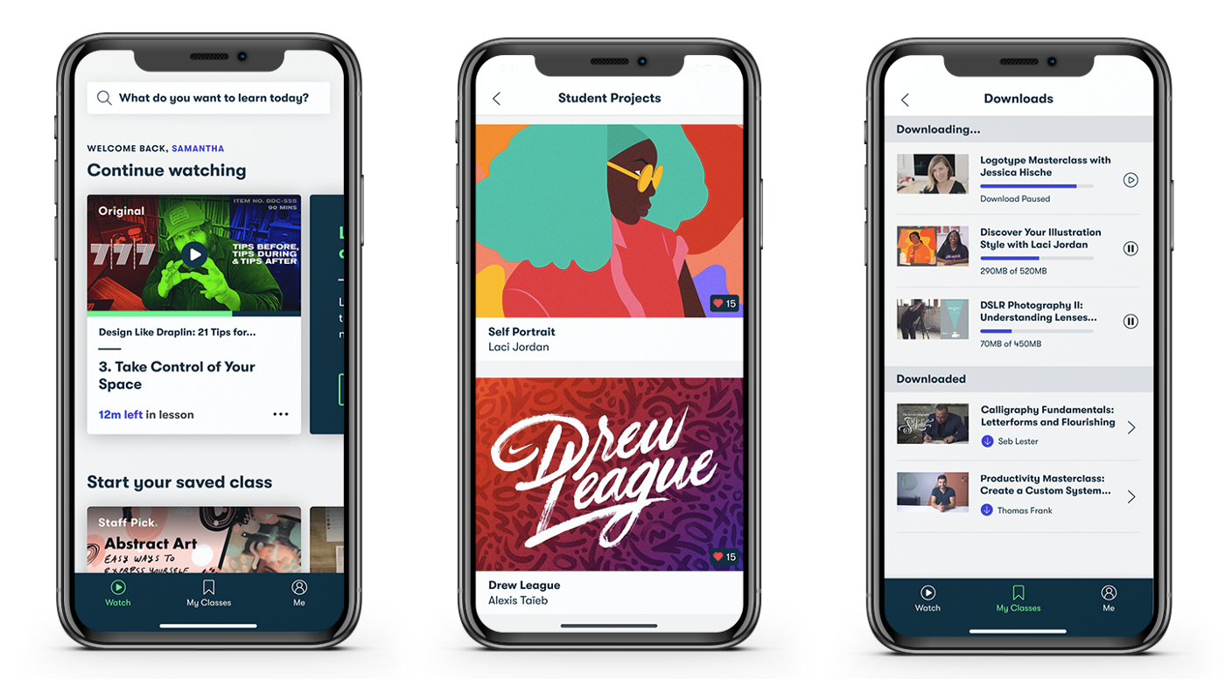

Figure Skillshare

2- Pluralsight: is the global leader in high-quality online training for hardcore developers and IT pros.

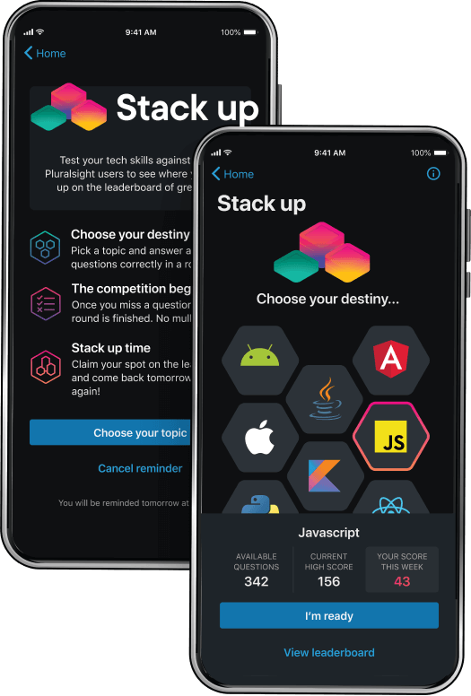

Figure Pluralsight

### 2.4.1 Gaps in Available Research

The major differences between our application and the two applications mentioned above that the meeting between the student and the talented is in person which helps with solving issues and sharing knowledge, it is more reliable for a student to meet with another student in person they both can express emotions and gain more experience.

The upside of our application is that the student/talented are in the same university so there will be no hard communication between them, unlike the mentioned applications. And the talented student can help beneficially from helping other people which will lead to upscaling the community.

# Chapter 3: Analysis Phase

**“In this section, we will deep dive into the Functional Requirements and Non-Functional Requirements, Hardware Requirements, UML diagrams, and Data Loggers”**

## 3.0 Functional Requirements

|  |  |  |
| --- | --- | --- |
| **ID** | **Title** | **Description** |
| 1 | Download Mobile app | A user should be able to download the mobile application through either an application store or similar service on the mobile phone. The application should be free to download. |
| 2 | Create account | User should be able to create an account. |
| 3 | Login | Students/Facility Members should be able to login with their credentials using SMS Verification code |
| 4 | Apply for a Talented Account | Students/Facility Members should be able to Apply for a Talented account. |
| 5 | Schedule Meetings | Users should be able to schedule a meeting with a Talented member. |
| 6 | Accept/Decline Requests | Talented member is required to accept/decline a meeting with a user. |
| 7 | Privacy | No one can see the phone number or email for any user for privacy concerns. |
| 8 | Chat availability | User can chat with a Talent member after order approval. |
| 9 | Create a Service | Users with Talented Role can create a paid/free service and show it to services page. |
| 10 | Request Service | Any user can ask for any service from any Talented member. |

Table 2 Functional Requirements

## 3.1 Non-Functional Requirements

|  |  |  |
| --- | --- | --- |
| **ID** | **Title** | **Description** |
| 1 | Performance | System should response to a user request within maximum time of 2 seconds (2000ms). |
| 2 | Scalability | System should be working fine with a large dataset and should normally operate. |
| 3 | Portability | System could be minimize & portable to users with a less complexity level. |
| 4 | Compatibility | System must be compatible with iOS and Android |
| 5 | Reliability | Users/Talented will be able to perform any task with 99% of time without issues |
| 6 | Maintainability | System should be able to resolve any issue on its own but, in cases of a high severity or critical issues, the maintenance should take less than four hours. |
| 7 | Availability | Users/Talented will be able to perform their usual tasks all the time, In the case of unplanned system downtime, all features will be available again after one working day. |
| 8 | Security | Users/Talented cannot see any data such as (email, phone number, etc..). |
| 9 | Localization | System should adapt English and Arabic languages with a smooth implementation to be able to add any language in the future. |
| 10 | Usability | System should be user-friendly and follows the principles and guidelines for User Experience |

Table 3 Non-Functional Requirements

## 3.2 Hardware Requirements

Minimum Requirements:

* Apple iPhone with A12 Bionic Starting from iPhone XS series until latest iPhone 14 series with at least iOS 12.6.
* Android Version 7.0 Nougat and newer.

Recommended Requirements:

* Apple iOS with A13 Bionic iPhone 11 series with iOS 16.0.
* Android Version 11.

## 3.3 UML Diagrams

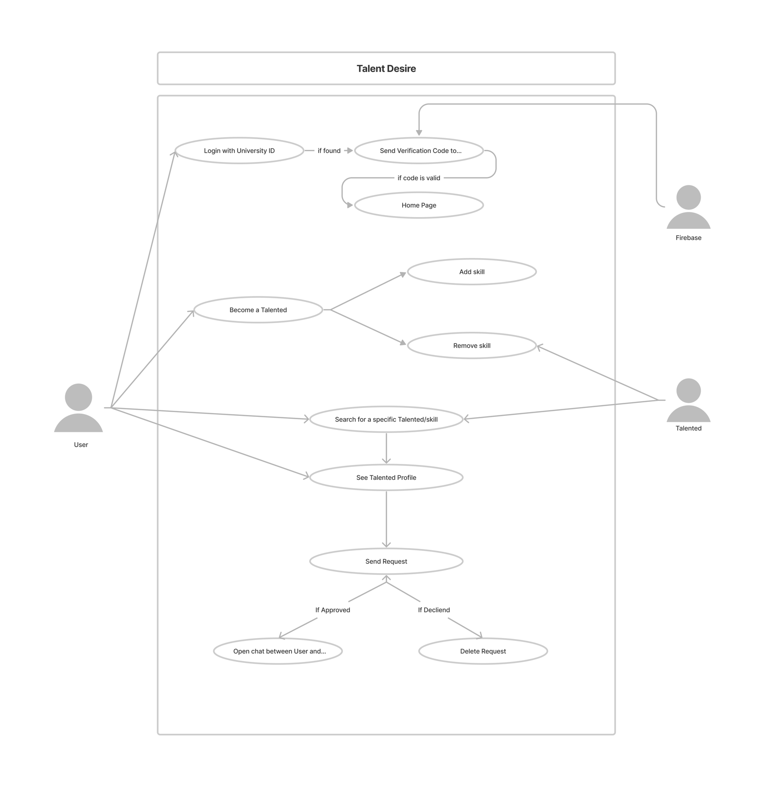

Figure Detailed Use Case Diagram

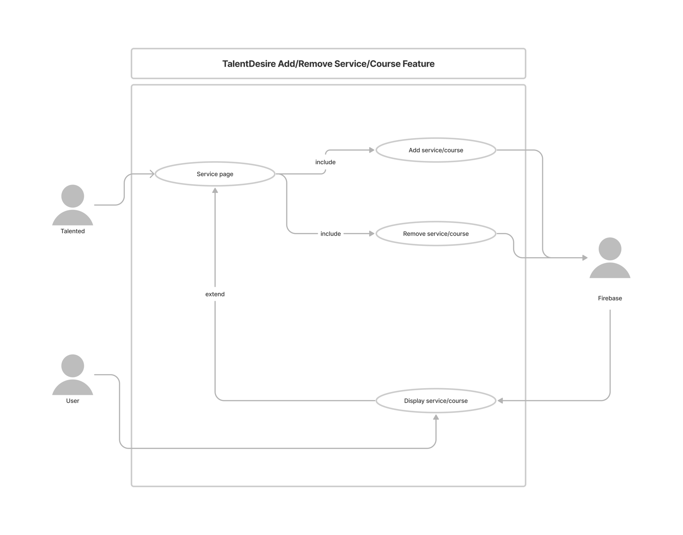

Figure 5 Add/Remove Course/Service Use Case Diagram

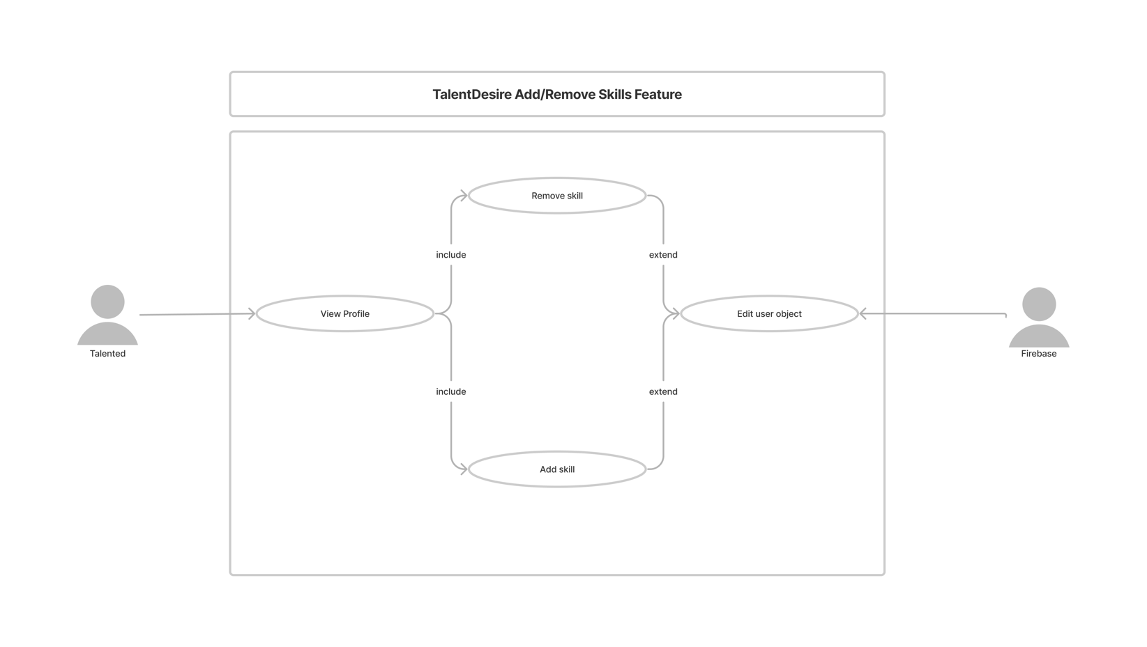

Figure Add/Remove Skill Use Case Diagram

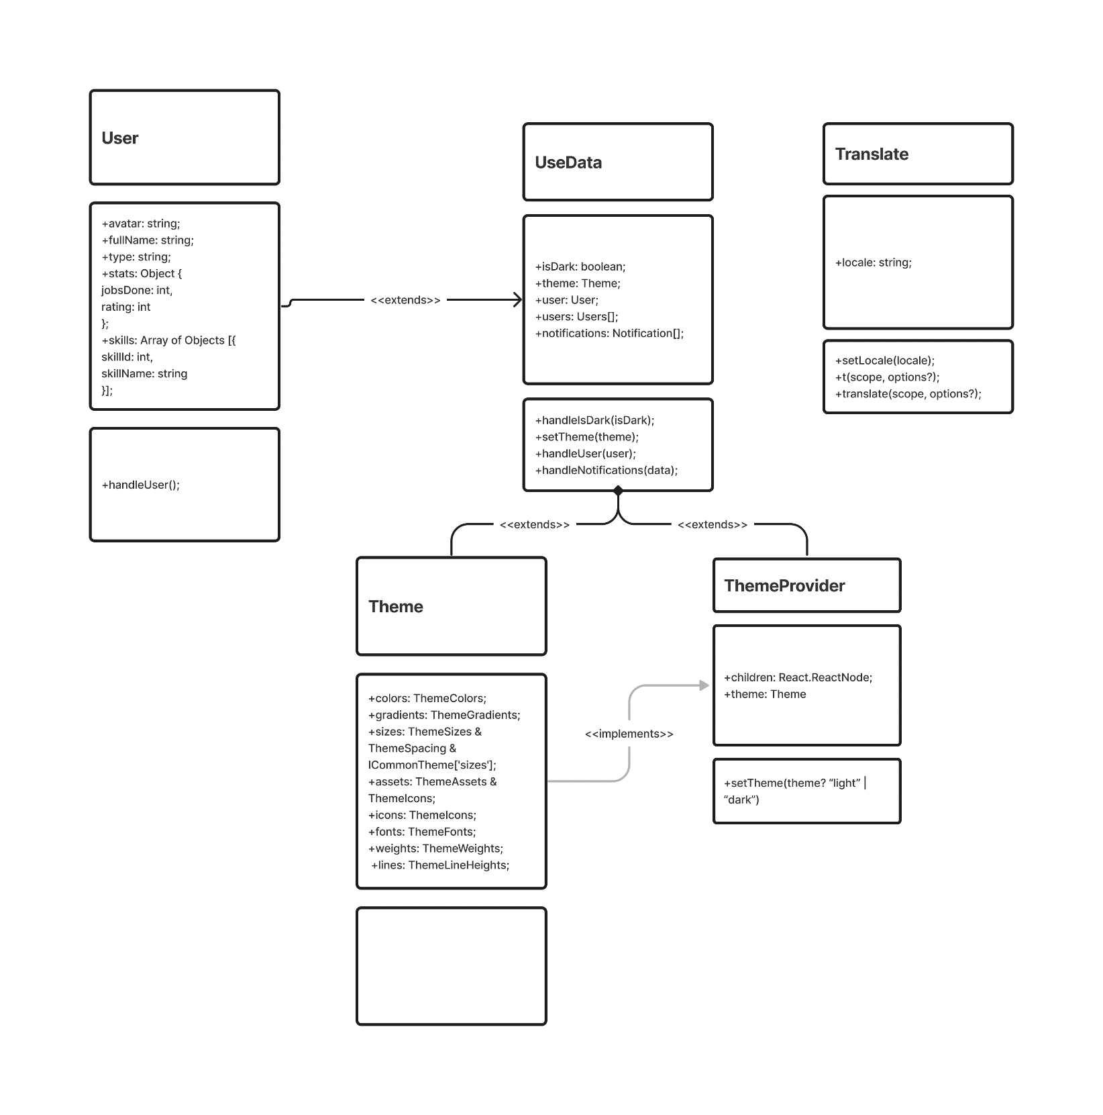

Figure 7 Class Diagram

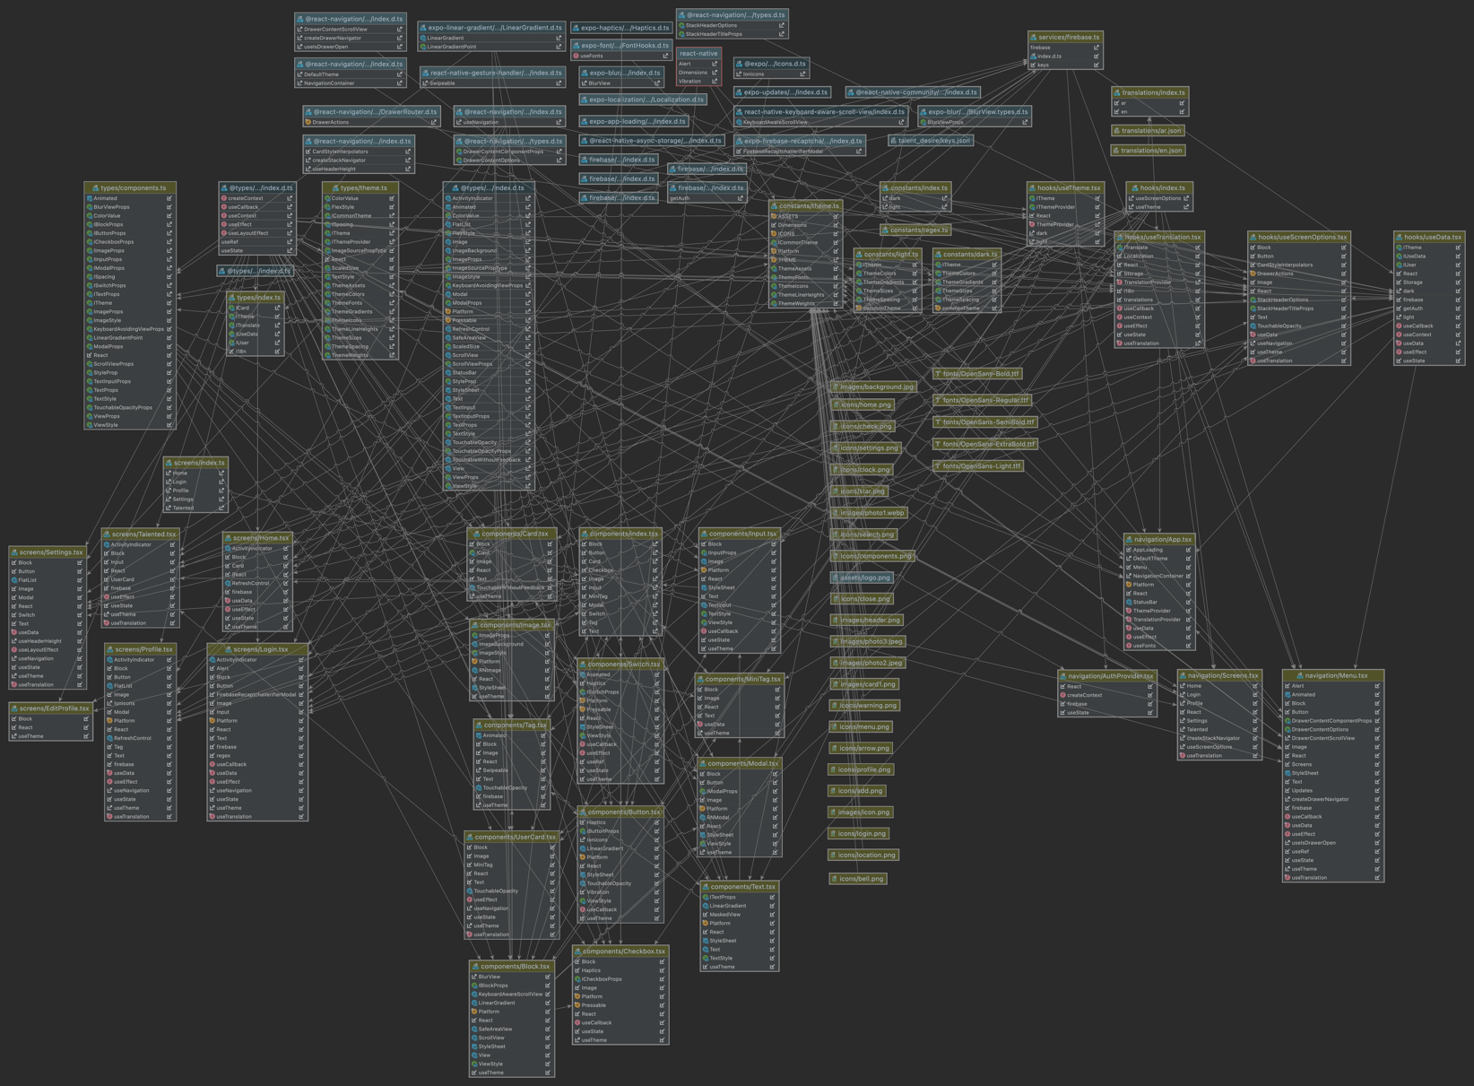

Figure 8 Detailed Class Diagram

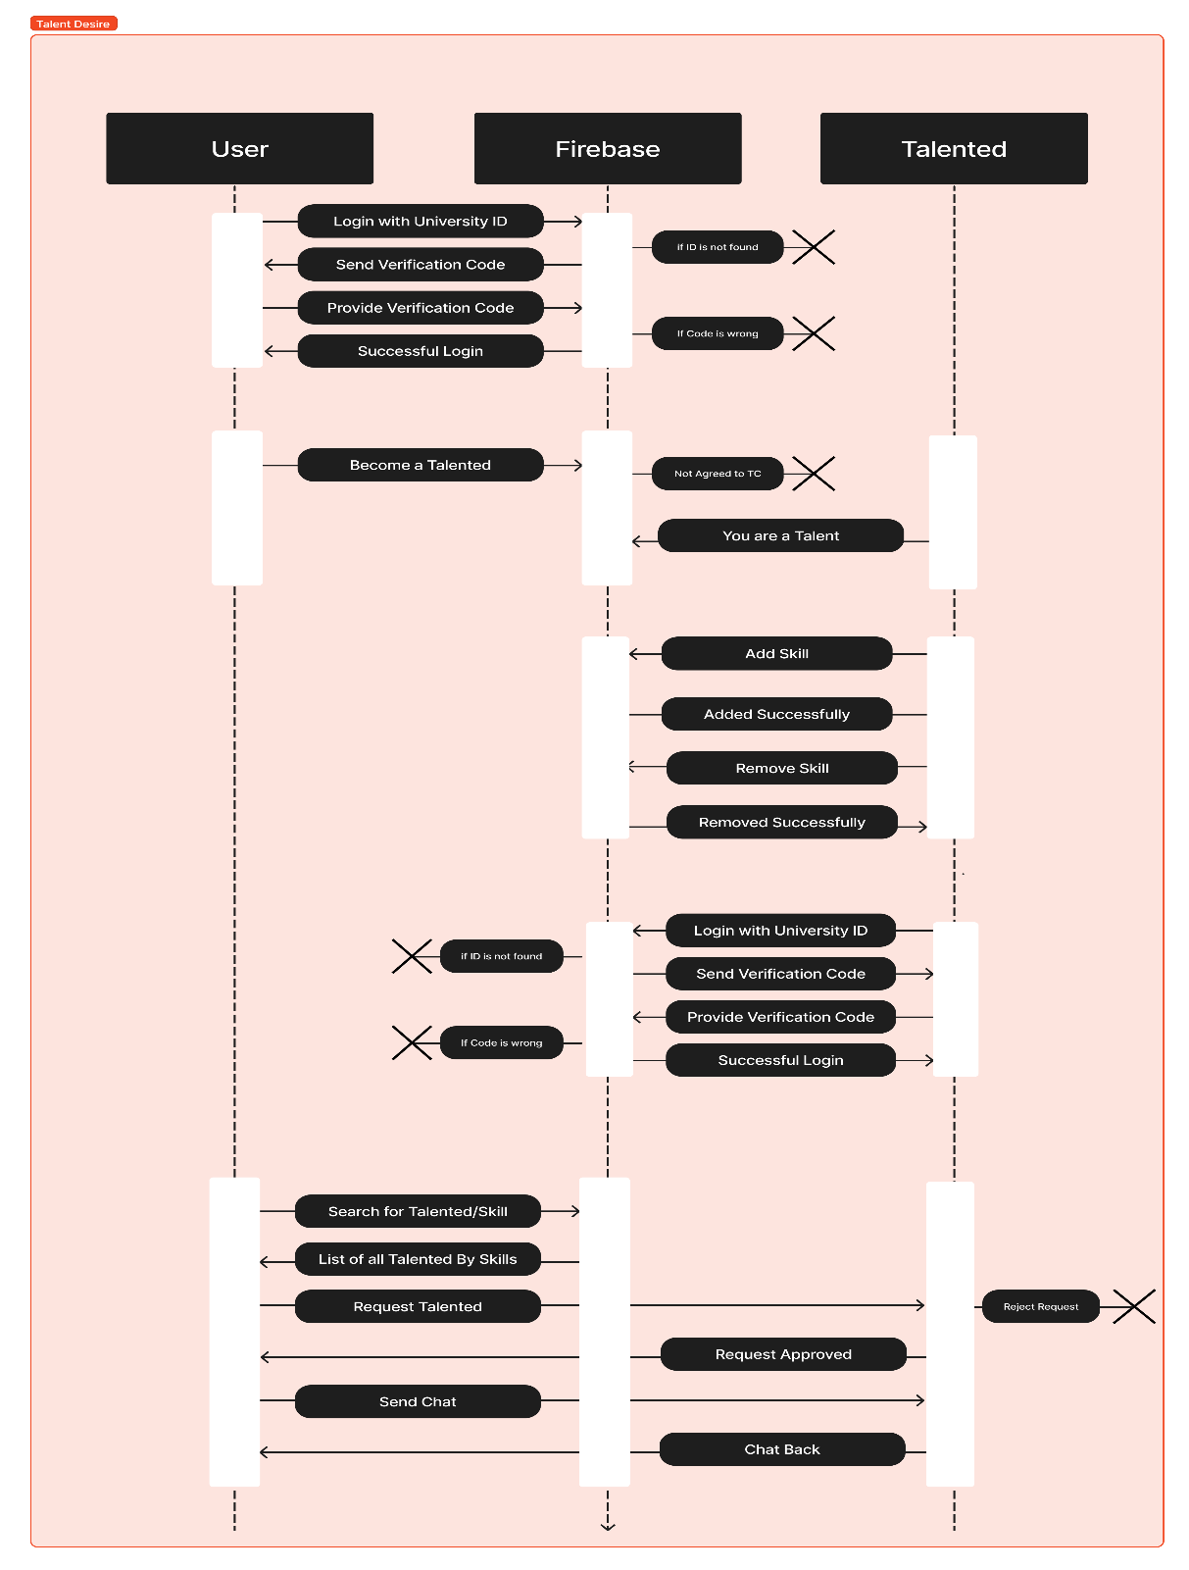

Figure 9 Sequence Diagram

|  |  |
| --- | --- |
| **Login Model** | |
| **Use case Id** | **UC01** |
| **Use case Name** | **Login** |
| **Actors** | **User & Talented** |
| **Preconditions** | **User must be registered to UJ Domain** |
| **Flow of events** | 1. **User enter their university id** 2. **User request a verification code** 3. **Code is sent to their phone** 4. **User provide code and login** |
| **Post conditions** | **System verify the user whether the information is correct or not.** |

Table 4 Login Model

|  |  |
| --- | --- |
| **Request Service Model** | |
| **Use case Id** | **UC02** |
| **Use case Name** | **Request Service** |
| **Actors** | **User & Talented** |
| **Preconditions** | **User must choose a Talented based on a service announcement from the Talented or from Talented page** |
| **Flow of events** | 1. **User/Talented enters the Talented profile/Service announcement** 2. **User/Talented request the Talented for help with a box of description** 3. **Talented will receive a notification in the Requests page, then he can either Accept or Decline the request** 4. **If declined the request will disappear, if accepted a chat will be opened for the User and Talented and they can contribute together where they can also schedule a meeting.** |
| **Post conditions** | **System verifies the user whether the information is correct or not.** |

Table 5 Request Service Model

|  |  |
| --- | --- |
| **Add Service/Course Model** | |
| **Use case Id** | **UC03** |
| **Use case Name** | **Add Service/Course** |
| **Actors** | **Talented** |
| **Preconditions** | **Only Talented members can add service/course** |
| **Flow of events** | 1. **Talented will be able to add service/course with a button click** 2. **Talented must provide more details in terms to add the service such as (Service/Course Name, determine if it is paid/free Service/Course, if it is a course then provide a date and seat limit and a classroom)** 3. **Service/Course will appear in a screen for users to apply.** |
| **Post conditions** | **System verifies if the entered data is valid.** |

Table 6 Add Service/Course Model

|  |  |
| --- | --- |
| **Enroll to a Course Model** | |
| **Use case Id** | **UC04** |
| **Use case Name** | **Enroll to a Course** |
| **Actors** | **User & Talented** |
| **Preconditions** | **Check if there is an available seat or not** |
| **Flow of events** | 1. **User/Talented can enroll to any course.** 2. **At the time of Course the Talented will check attendance, to provide more security users will have to accept Talented attendance request.** 3. **System will create an invoice for user and a notification to the Talented** |
| **Post conditions** | **System validates if Talented & User are together and will create an invoice.** |

Table 7 Enroll to a course

## 3.4 Data Collection Instruments

We have conducted a survey to help us understand user needs and functional/non-functional requirement, so we have targeted student to achieve our goals.

### Survey design



Figure 10 Survey Flyer

### Survey Analysis

7 participants

Ages between 20-24

Between Level 7-10 From Software Engineering Department

### Survey results

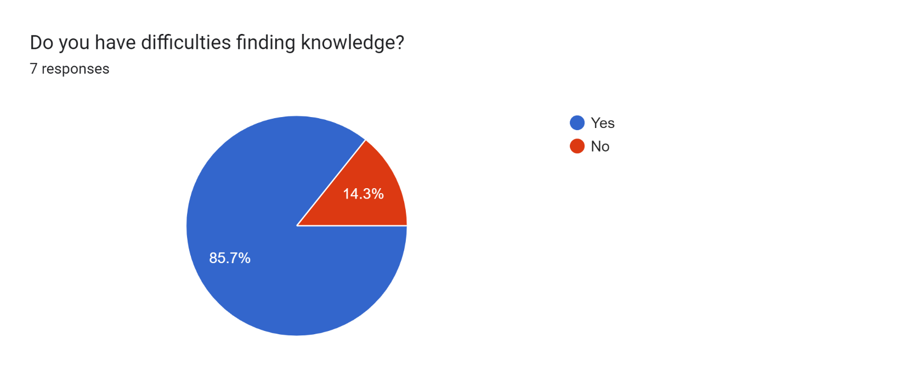

Figure 11 Pie Chart for question 1

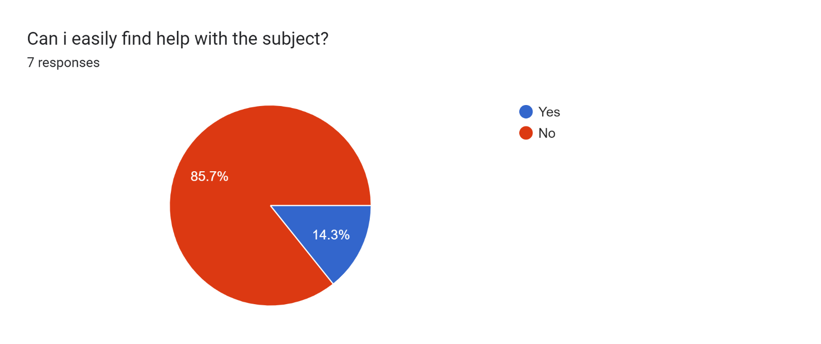

Figure 12 Pie Chart for question 2

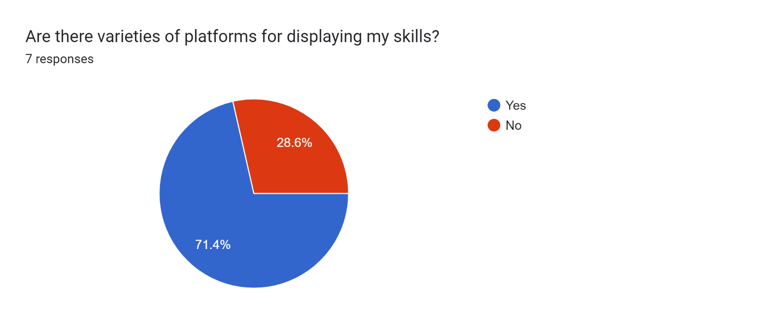

Figure 13 Pie Chart for question 3

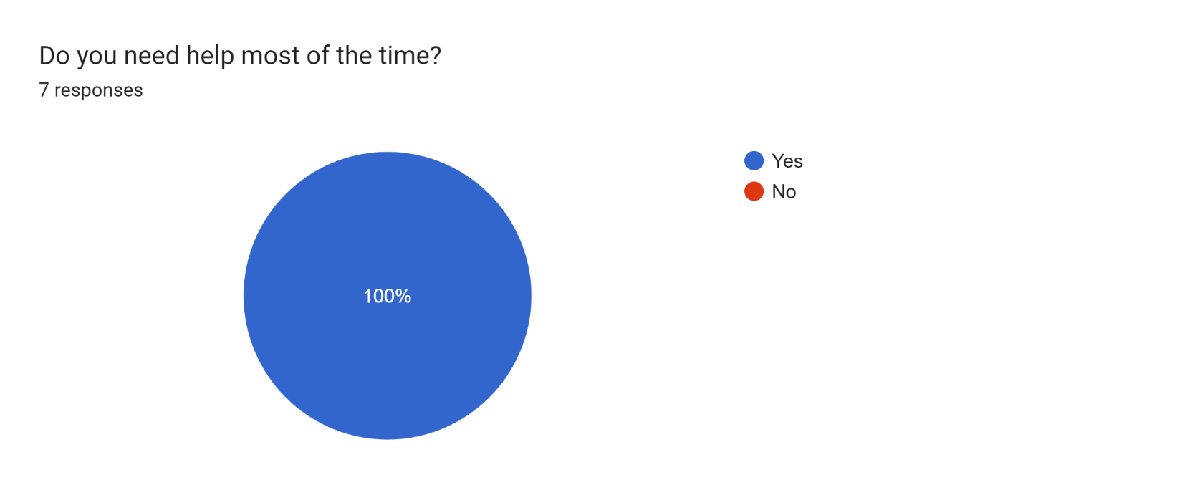

Figure 14 Pie Chart for question 4

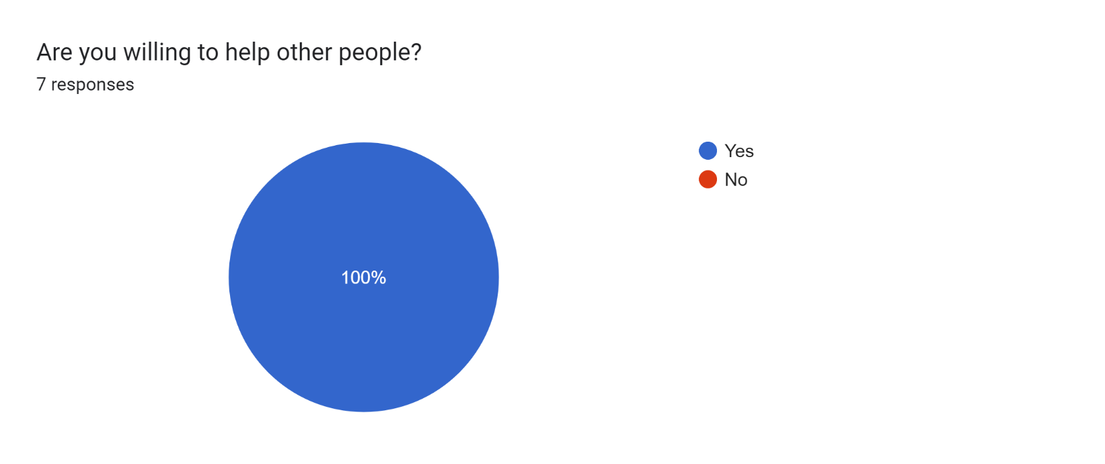

Figure 15 Pie Chart for question 5

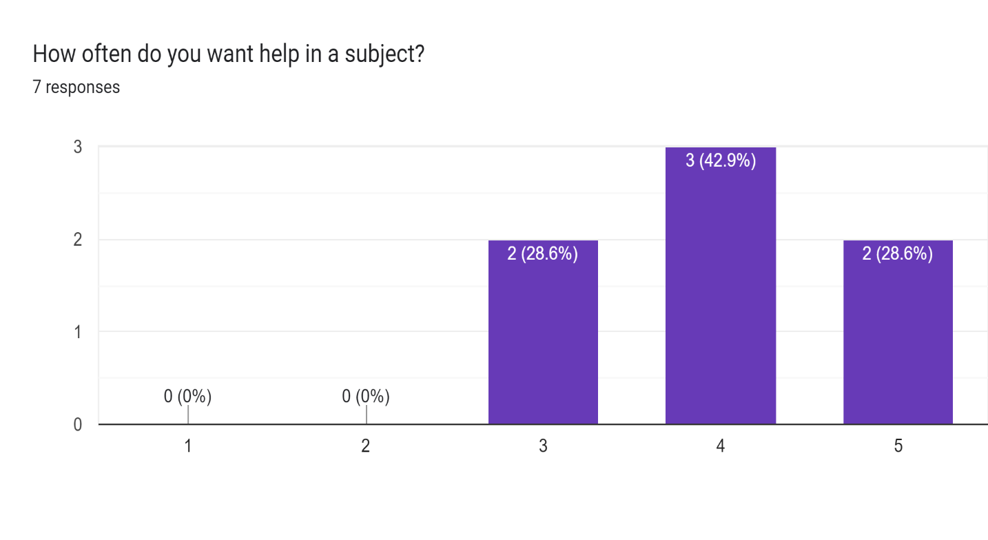

Figure 16 Pie Chart for question 6

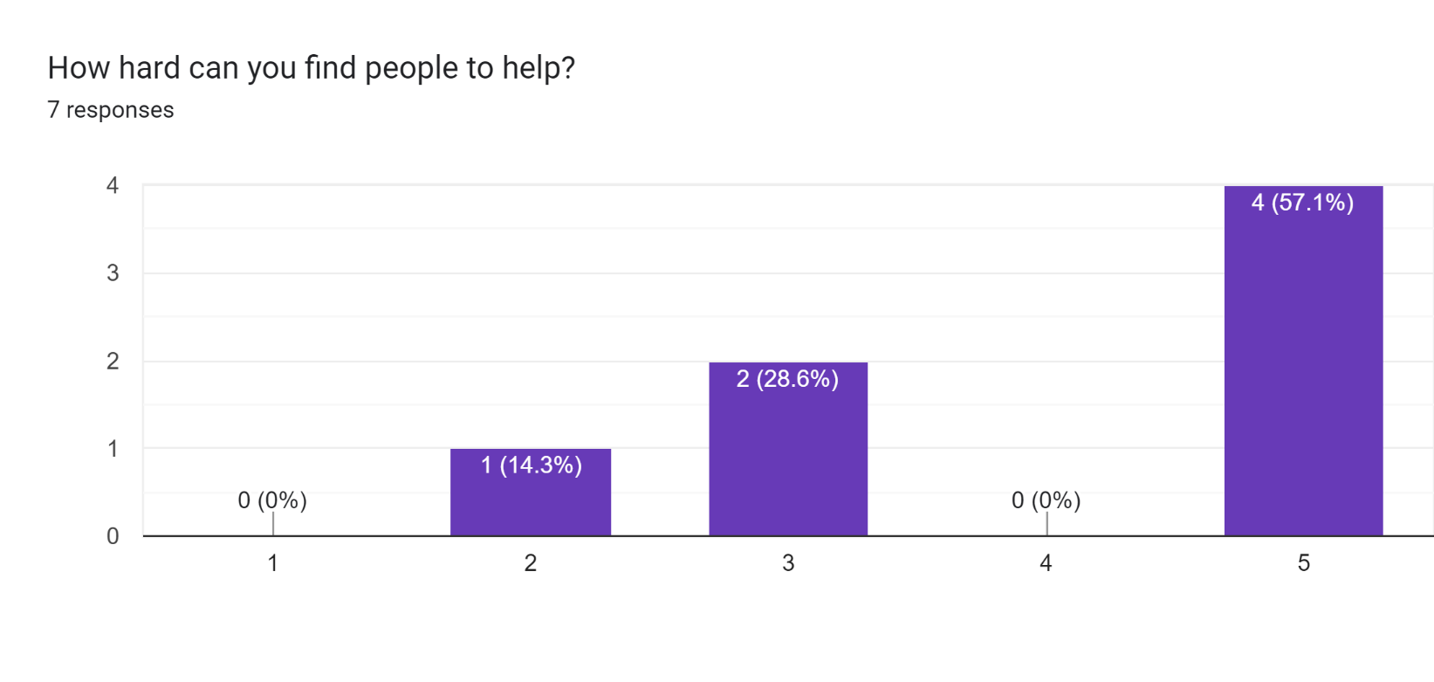

Figure 17 Pie Chart for question 7

# Chapter 4: Design Phase

**“In this section, we will look more into our System Architecture, Diagrams, and we will look into our beautiful User Interface”**

## 4.0 System Architecture

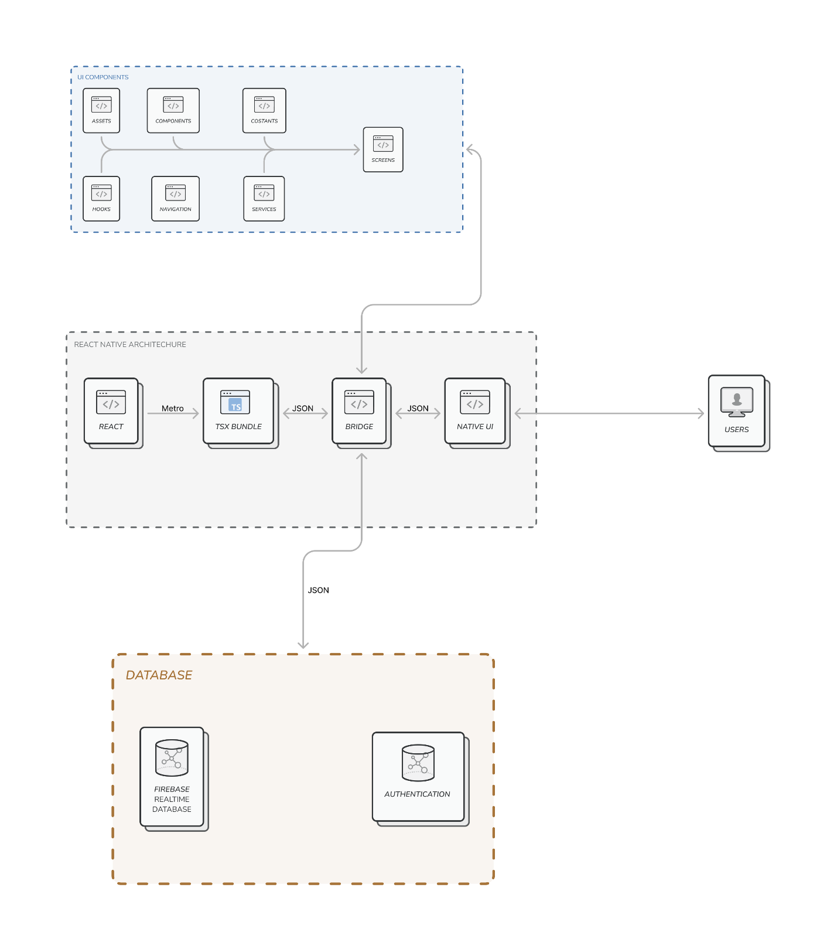

Figure 18 System Architecture

## 4.1 Diagrams

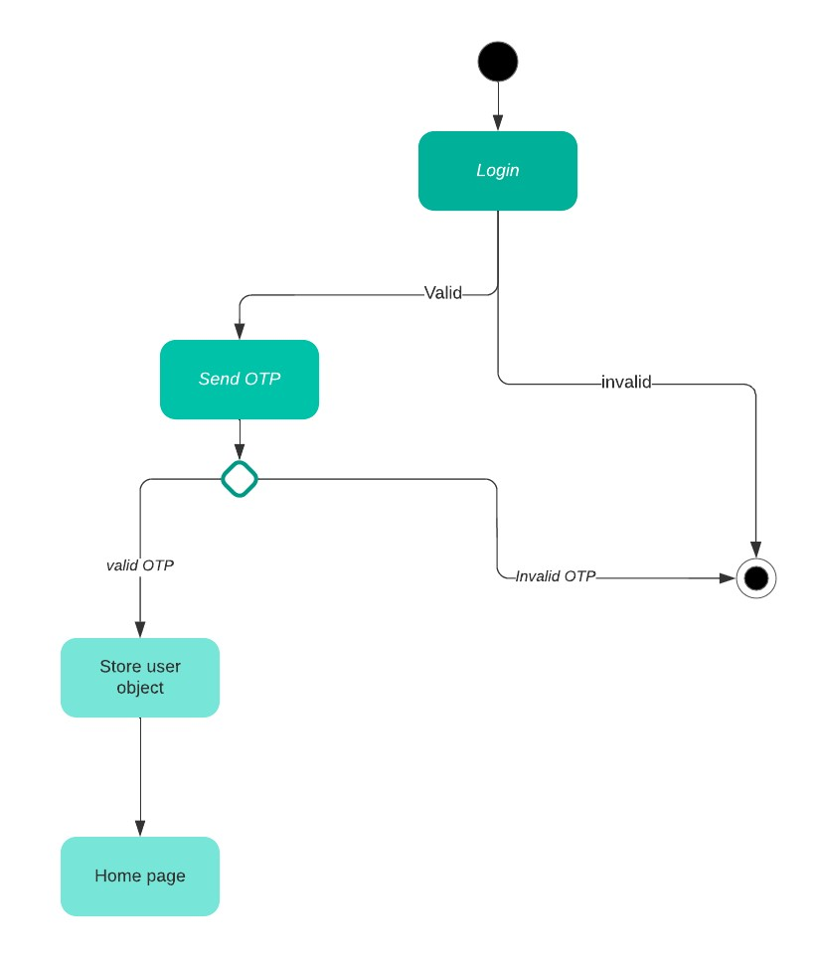

Figure State Diagram for Login Model

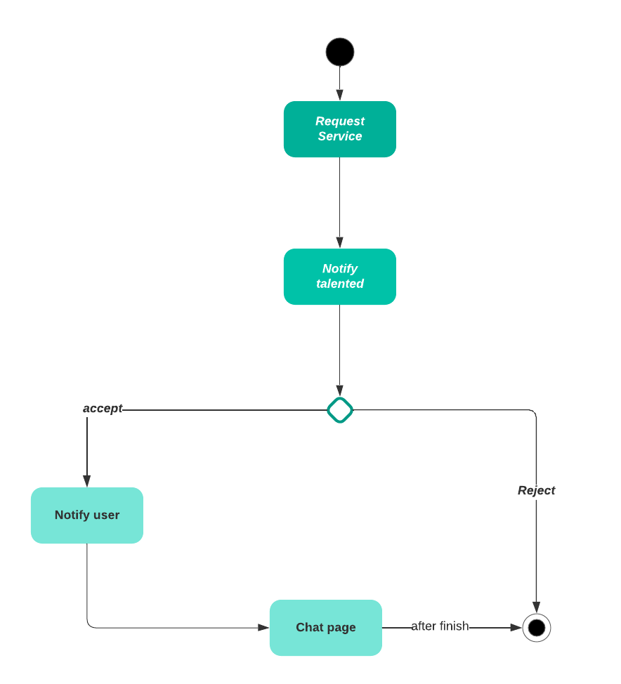

Figure State Diagram for Request Service Model

## 4.2 User interface design

|  |  |
| --- | --- |
|  | **Loading Screen (Splash Screen)** |
|  | **Greetings screen with access to navigation bar on the top.** |
| **صورة تحتوي على نص  تم إنشاء الوصف تلقائياً** | **The login page allows the user to enter the system.** |
|  | **The setting page allow you to change language and dark mode.** |
|  | **The profile page of talented user, where he can add/remove skills and see his rating, etc..** |
|  | **Talented page is to display talented users and their skills.** |
| **صورة تحتوي على نص  تم إنشاء الوصف تلقائياً** | **Navigation bar that shows all pages and the login button.** |
|  | **The page is example of dark mode and the Arabic language.** |

Table 8 User Interface Design

# Chapter 5: Conclusion

**“In this section, we will inform you how we started and how we are going so far”**

## 5.0 Conclusion

We had conducted everything so far, we are working on implementing this project and bring it to life, we are so excited to announce that it is already on the way to become a reality, after a long journey of searching and research and interviews with UJ students we had concluded, this is a mandatory tool for UJ students.

## 5.1 Future Work

We studied the market and the programming languages that is a hit now, we knew that every stunning application comes from a great implementation method, so we chose to use React Native as a cross-platform development with TypeScript Programming Language, we are mocking UJ Database using Firebase Real-time Database, we will conduct more studies and methods at the next semester.